A-1



A-2

STEPS

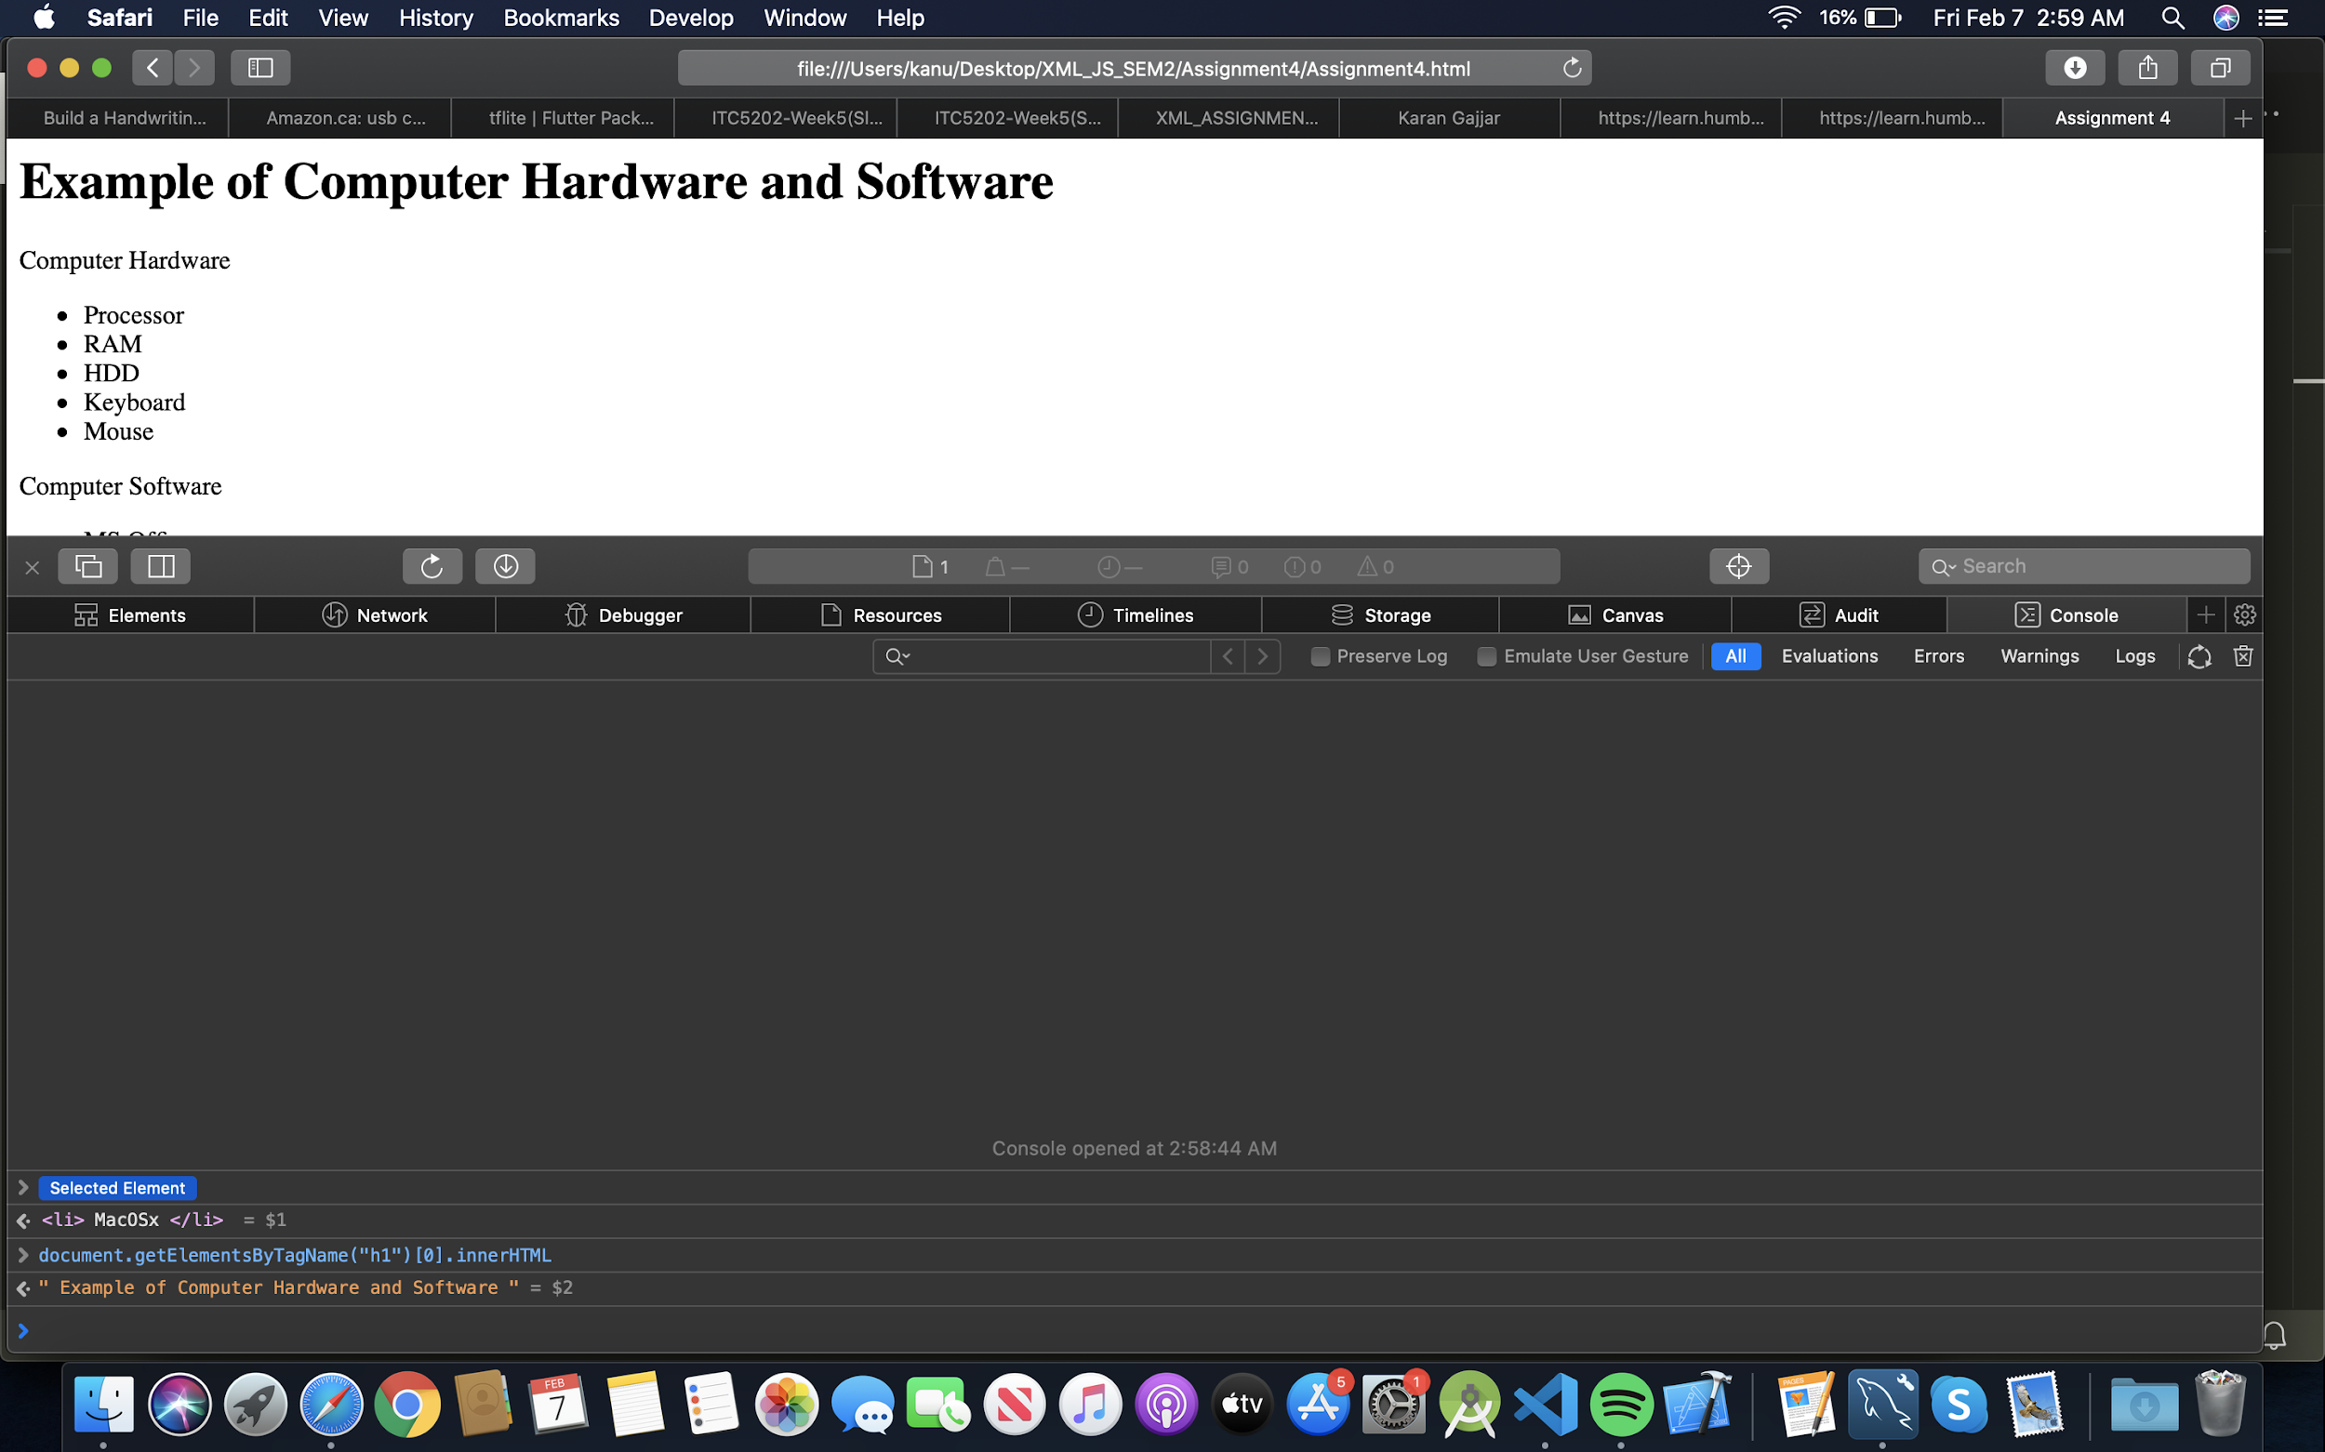

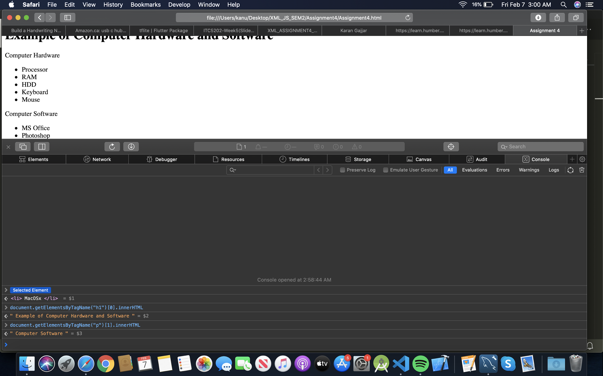



Node : An HTML element is a node

Node type : Node type is an integer that indicates the type of the node.

**Explanation : Here LI is ELEMENT_NODE as it has value 1**

Node name : The nodeName property returns the name of the specified node.

– If the node is an element node, the nodeNameproperty will return the tag name.

– If the node is an attribute node, the nodeNameproperty will return the name of the attribute.

**Explanation : In our example nodename will be LI**

The nodeValue property sets or returns the node value of the specified node.

– Returns null for element nodes and document nodes

– Returns the value of the attribute for attribute nodes

**Explanation : Null for our case.**

STEP 8 :

Safari was not able to display.

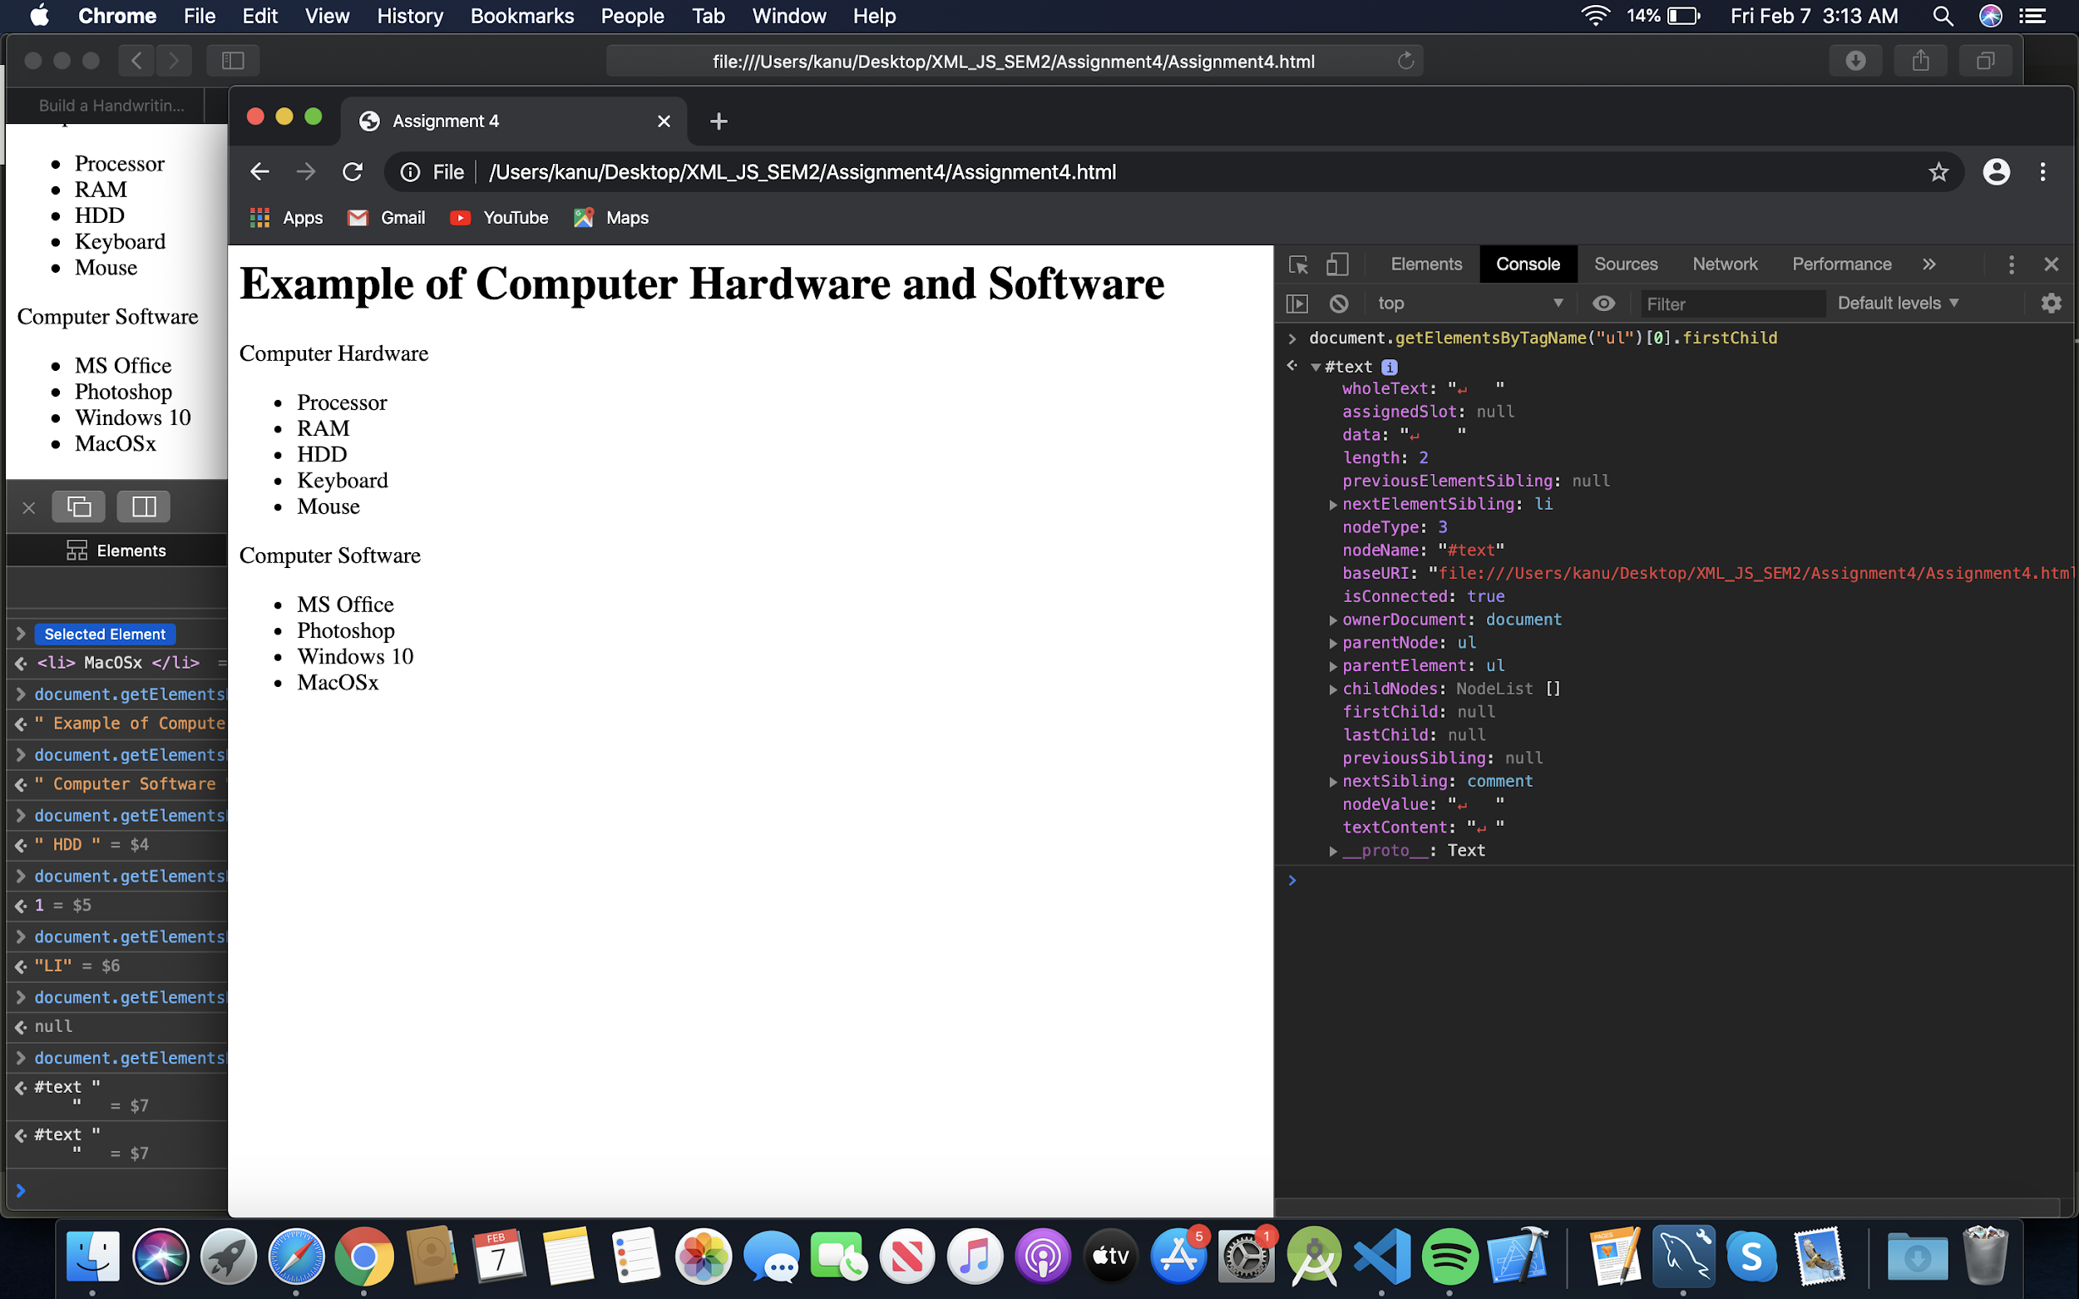

**YES nextSibling is javascript property.**

The **nextSibling** property is used to return the next node of the specified node as Node object or null if the specified node is the last one in the list.

Return value: This property returns a next sibling of the specified node or null if the current node has no next sibling.

nextSibling is comments with data :

<!-- components inside computer case -->

So nodeType **8** is used as a COMMENT_NODE

Step 9 )

